Creating New Characters For Smartbody

1.0 Introduction
This document is intended as a guide for successfully exporting new skeletons and animations for use in the Smartbody Virtual Human system.

2.0 Getting Started
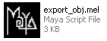

First you will need to locate the OBJ/SK/SKM Maya Export .mel files, and for simplicity, you are going to place them in your local Maya “Scripts” folder. This folder is generally located here:

C:\Documents and Settings\(USER)\My Documents\maya\7.0\scripts

After placing the .mel scripts in the appropriate folder run Maya and in the menu select: Window > General Editors > Script Editor …

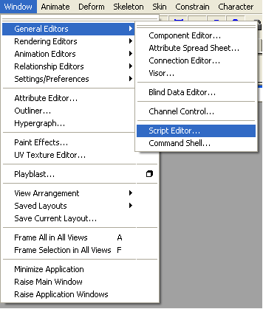

In the script editor clear the history: Edit > Clear History

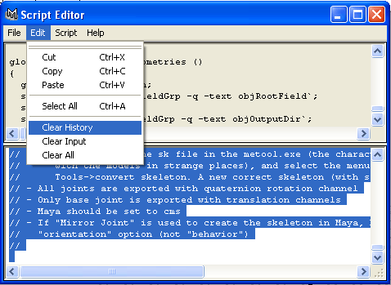

Load the script into the editor: File > Open Script … Browse to the appropriate file and open it.

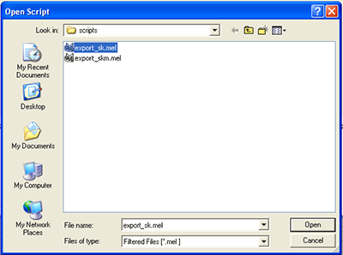

Place the cursor in the lower half of the script editor where your new script has been loaded and select: Edit > Select All

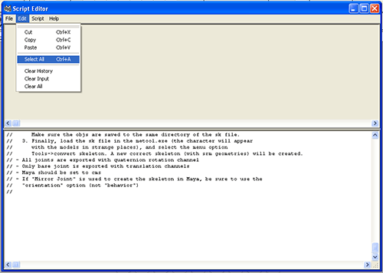

Now, save your script to a Maya shelf. You can create a new shelf or use maya’s “Custom” shelf. Make sure that the destination shelf is active when you attempt to save the file: File > Save Selected To Shelf …

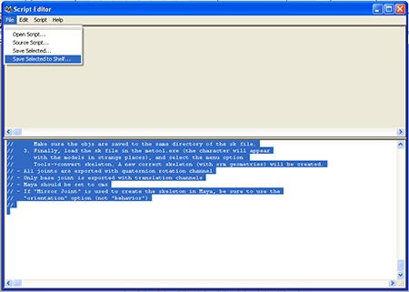

Name your new shelf something simple like “SK” for the .sk skeleton
exporter or “SKM” for the .skm animation exporter etc …

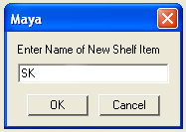

Continue to create shelves in the same manner for the remaining export
scripts.

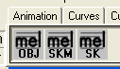

3.0 Preparing the Model for Export

There are a few thing that you must be aware of before you can
Successfully export a new skeleton.

1) Within your Maya model and skeleton file you will need to create a
stripped down “Proxy” representation of your character. The .SK skeleton exporter does not currently support smooth or rigid bound skins.

2) To create an acceptable export model you will need to create a polygonal
“rigid” body made up of representational blocks of geometry that will
still move and rotate in a convincing way.

This is an example….

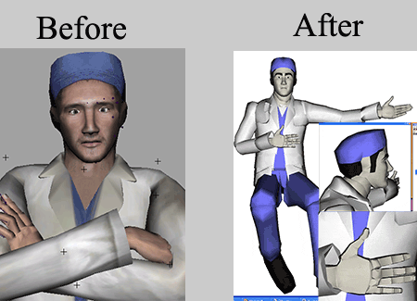

4) Strip the skeleton of any controllers/rig. Make sure the model is in its
default “Bind Pose” or “T” pose, with the Hips or “base” bone located
at the origin (0,0,0).
Make sure that all of the joint rotations are set to “0”.

The system currently supports facial bone translations. To activate this feature you will need to set Translation limits on the facial bones that you wish to animate. Any translation limits set will be recognized by the .SK exporter and handled accordingly.

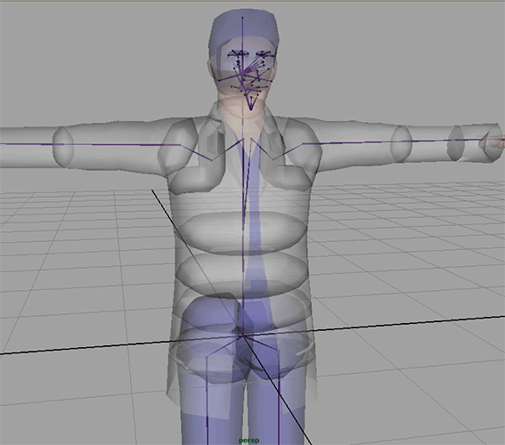
Note the “base” bone is located at (0,0,0)

5) Now, if you have not already done so, connect the new rigid model
(proxy) geometry by parenting it to the corresponding bones. If the
geometry has already been parented to the bones (as in the example
seen on the previous page) then you may skip this step.

Remember to delete any smooth or rigid bound skins.

6) Clean up the scene. Go to: File > Optimize Scene Size (option box)

- Check all and click “Optimize” at the bottom of the tool window.

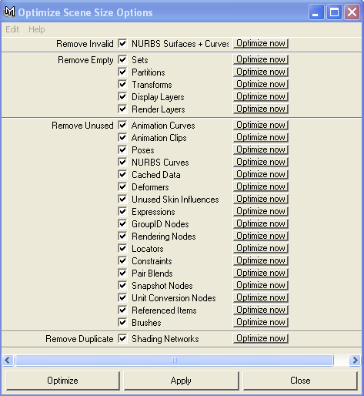

4.0 Exporting Your Skeleton (.SK Export)

1) Prepare your export by first creating a within your working
directory.

2) Make sure to load your model into Maya.

3) Activate your “SK” export button 

4) Browse to you working directory. Save your .sk file into the
“NewFolder”
5) Click on “Export” in the .sk exporter.

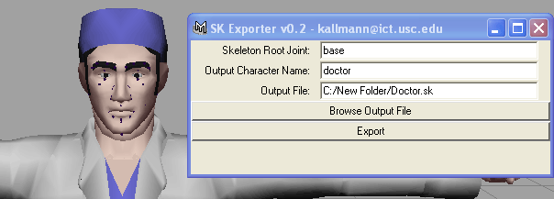

5.0 Exporting Your Geometries (.OBJ (.MTL) Export)

1) Activate your “OBJ” export button 

2) Browse to your working directory. Save your .obj files into the (same)
“NewFolder”

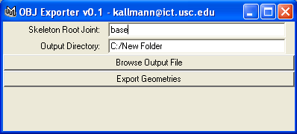

3) Open the script editor to monitor the export. Click on “Export
Geometries” in the .obj exporter.

You should see something similar to this in the MAYA script editor:

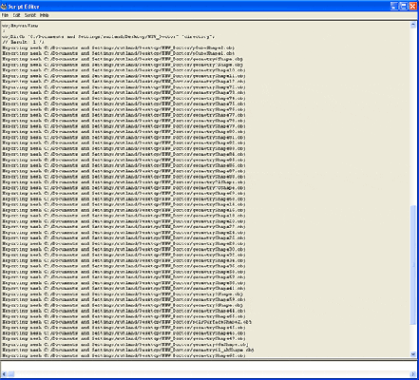

6.0 Building the Skeletal Definition for Smartbody

1) Copy transeditor.exe into the “NewFolder”. This folder should also
contain the previously exported SK/OBJ/MTL files.

Create a new folder “NewFolder(2)” within your working directory. This
“NewFolder(2)” is your final destination folder.

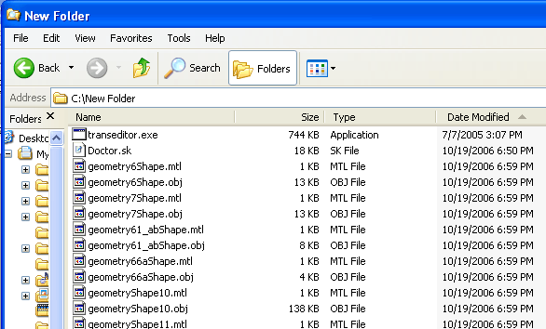

7) Run transeditor.exe. Select the .sk file that is in your “NewFolder”
and click OK.

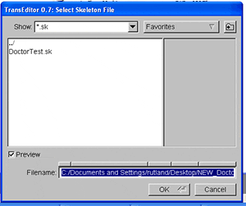

8) When the program prompts you for the Motion Engine (.me) file, ignore
the prompt and hit “Cancel”.

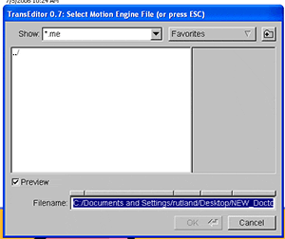

9) You should now see your exploded skeleton geometry.

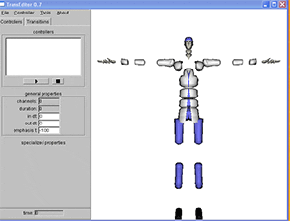

10) Go to: Tools > Convert Skeleton

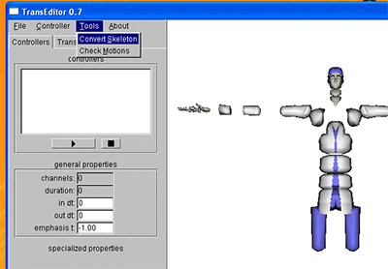

Give your skeleton a name. The same .SK filename is fine. If you have not
yet done so, create a new folder “NewFolder(2)”. This
“NewFolder(2)” is your final destination folder.

At the Convert: Select output directory: prompt, choose the
“NewFolder(2)” as your final output directory.

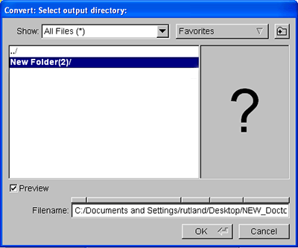

11) When the program asks you to “Remove collision geometry” click
YES.
Note: If you are going to use the existing "collision" geometry
click No.

12) You should now have .srm files and your final .sk file located in the
“NewFolder(2)”

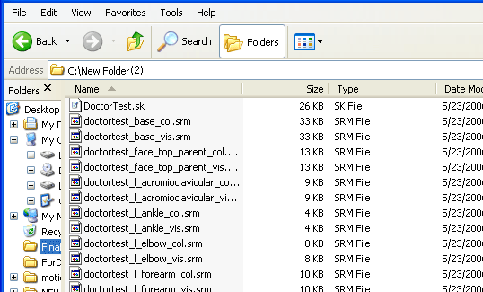

Exporting Animation For Smartbody

Before You Begin:
If you have not done so already, please refer to 2.0 Getting Started
for a guide to creating a .SKM export button within the Maya interface.

7.0 Using the .SKM Animation Exporter

The .SKM animation Exporter allows you to export animation files that can be used by smartbody. To use the exporter, first open the given Maya animation you want exported. We will explore the exporter functions first.
Activate your “SKM” export button  that can be found on your Maya shelf.

After running the script, the following dialogue box will appear.
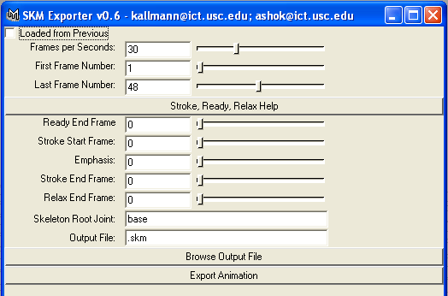

The First Frame Number (given an initial value of 1) and Last Frame Number (given an initial value of the last frame # in the animation or *See Note Below*) slider allow you to control the time slider so that one can scan through all the frames of the animation to decide which should be the first and last animation frame. These also adjust the start and end time playback parameters in the animation file itself. Adjust these to the correct values.
**Note: If your animation file spans beyond 100 frames the initial value of the last frame will be 100. You must change the Value to the last frame of your animation **

Notice that Ready End Frame, Stroke(Emphasis) End Frame, and Relax End Frame sliders are adjusted appropriately such that the lowest value they can be given is the First Frame Number and the highest value they can be given is the Last Frame Number.
Adjust the Ready End Frame, Stroke End Frame, and Relax End Frame (These sliders also control the time slider to easily see where one is in the animation)- where ready, stroke, and relax are defined as follows:
**Note: Some of the values may/can be the same value. ie. The “ReadyEndFrame” and “StrokeStartFrame” can both theoretically have the same value. This holds true for all of the sliders.
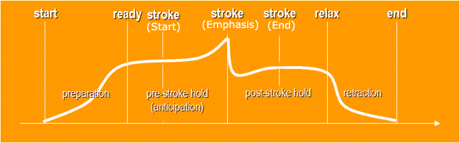
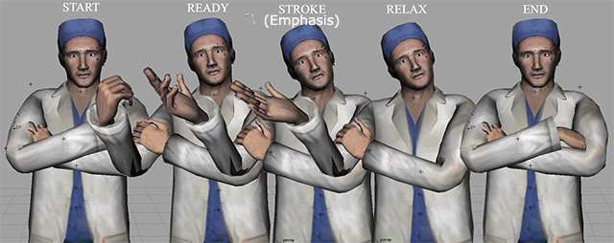

Every behavior is broken down into four phases, defined by five points in time (see image). These points provide "significant points of alignment" between behaviors. The preparation for or visible anticipation of the behavior occurs between start and ready, and the retraction back to neutral or previous state occurs between relax and end. The actual behavior takes place between the ready and relax, with the most effortful part coinciding with the stroke(emphasis) point. If the behavior does not involve a single moment of greatest effort, the stroke(emphasis) assumes the same time as ready. For example, looking at something will only involve ready (the time of making eyecontact) and relax (time of breaking eyecontact). If no preparation or relaxation is needed, then start and ready refer to the same point in time, and relax and end refer to the same point in time.

Also, one can click the Stroke(Emphasis), Ready, Relax button on the exporter to get a quick description of each. Note that one should specify the end frame of the gesture’s ready, stroke(emphasis), and relax.

Keep in mind that
Ready End Frame < or = Stroke Start Frame
Stroke End Frame < or = Relax End Frame
If this condition is not met, the script will not allow you to export.

In the output file text box put the complete path of the file (it will take the path of the animation file by default and suggest a name that is the animation file name followed by a “.skm”). For example, one might save the animations to the directory \saso\core\smartbody\testdata\doctor\motion\testAnimation.skm
(in this case the .skm name is “testAnimation”)

8.0 Preparing Your Animation for Export

Before you export you should also note/check the following:
- The order of the joint rotations is considered to be Euler XYZ
- You cannot change the default name of the animation curves (they have to have the form jointName_rotateX, etc)
- If the animation uses IK handles or controllers, it must be baked before the export
To do so go to: Edit > Select All by Type > Joints
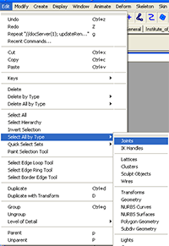
Then go to: Edit > Keys > Bake Simulation > (OptionBox)
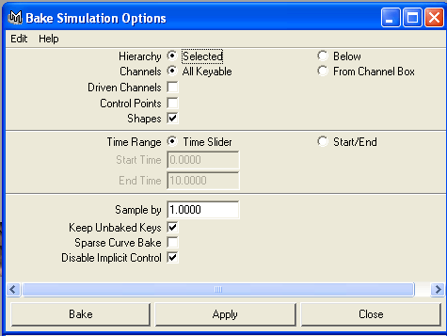
Make sure these are the options (default Maya) that you see …

- After the bake is completed make sure that the character’s waist bone “base” is at or near (0,0,0) before export. Depending on the animation the character may rise or fall below the origin but the start/end frames should be as close(relative to the pose) to (0,0,0) as possible.
The character’s height above the smartbody “environment” floor is controlled with the “base” bone.
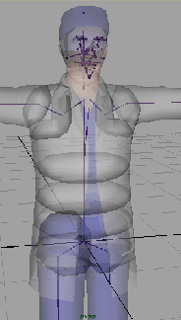
- To make sure the animation export will be fine, remove all IK handles and check if the animation in Maya is still correct
- Although the script checks it, it is a good idea to change the settings to cms
- Note: a quaternion channel is stored with a 3D vector: its length is the angle and the vector is the rotation axis

9.0 Export Your Animation

Activate your “SKM” export button that can be found on your Maya shelf.

Browse to your destination folder and select a file name. Set your values and select: “Export Animation”.

When your export is done the Script editor will notify you:

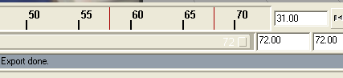
Note: If the animation is 200 + Frames or more you will have long wait times for exports. Exports of 900 Frames or more can sometimes take as long as 10-20 minutes + …..

Before Closing the Maya Animation File, SAVE the Maya (.ma/.mb) Animation File. This will allow for the Ready, Stroke, and Relax data to be saved inside the animation file-- the scenegraph will now contain the empty nodes ready, stroke, and relax, whose values can be found under “additional attributes.” Furthermore, if you load up the .skm Exporter script from a previously exported and saved animation the values are immediately set for each parameter, and the Loaded From Previous box is checked so that one knows that the animation has already been exported once before.

.SKM Representation of Ready, Stroke, Relax:
In the actual .SKM file, the data is represented, in seconds, at the bottom of the file--2 lines after the final keyframe-- as follows:

(Keyframe data). . . . . 0 0 0 0.02403 -0.21483 -0.07251 0.21243 0 0 -0.21554 2e-005 0.00352 0 0 0 0 0 0

ready time: 0.8333333333
stroke time: 1.233333333
relax time: 2.066666667
-End of File-

Motion Engine Representation of Ready, Stroke, Relax:

The ready, stroke, and relax data can be found in the float ready, stroke, relax member variables of the class sk_motion.h . They can be set and read internally via the get/set ready, stroke, relax commands. The data is read in from a motion (.SKM) file itself in sk_motion_io.cpp. If no ready, stroke, and relax data exists or the data is invalid, the following error message is outputted to the sbm window
WARNING: ATTEMPT TO LOAD SKM WITHOUT READY,STROKE,RELAX METADATA : (motion name)
And the that motion’s ready,stroke,relax values are all set to -1.

